**4.0 SYSTEM ANALYSIS**

**4.1 STUDY OF CURRENT SYSTEM**

In the present system all work is done on paper. The whole session attendance is stored in register and at the and of the session the reports are generated.

**4.2 PROBLEM AND WEAKNESSES OF CURRENT SYSTEM**

• Not User Friendly: The existing system is not user friendly because the retrieval of data is very

slow and data is not maintained efficiently.

• Difficulty in report generating: We require more calculations to generate the report so it is generated

at the end of the session. And the student not get a single chance to improve their attendance

• Manual control: All calculations to generate report is done manually so there is greater chance of

errors.

• Lots of paperwork: Existing system requires lot of paper work. Loss of even a single register/record

led to difficult situation because all the papers are needed to generate the reports.

• Time consuming: Every work is done manually so we cannot generate report in the middle of the

session or as per the requirement because it is very time consuming.

**4.3 REQUIREMENT OF NEW SYSTEM**

**4.3.1 Functional Requirements**

1) First time login page.

2) Student Signup Page.

3) Select campus Drive and enroll in it.

4) Scan barcode with changing images.

5) Professor log in page and attendance taking page.

6) Send data to server and process.

7) Professor make campus drive option.

8) Professor should see total number of students present at attendance time

9) send Result of each round.

10) View result by all students.

**4.3.2 Non Functional Requirements**

* [Accessibility](https://en.wikipedia.org/wiki/Accessibility)
* [Adaptability](https://en.wikipedia.org/wiki/Adaptability)
* [Auditability](https://en.wikipedia.org/wiki/Auditability) and control
* [Availability](https://en.wikipedia.org/wiki/Availability)
* [Backup](https://en.wikipedia.org/wiki/Backup)
* [Capacity](https://en.wikipedia.org/wiki/System_capacity), current and forecast
* [Certification](https://en.wikipedia.org/wiki/Certification)
* [Configuration management](https://en.wikipedia.org/wiki/Configuration_management)
* [Cost](https://en.wikipedia.org/wiki/Cost), initial and [Life-cycle cost](https://en.wikipedia.org/wiki/Life-cycle_cost)
* [Data integrity](https://en.wikipedia.org/wiki/Data_integrity)
* [Data retention](https://en.wikipedia.org/wiki/Data_retention)
* Dependency on other parties
* [Deployment](https://en.wikipedia.org/wiki/Software_deployment)
* [Development environment](https://en.wikipedia.org/wiki/Development_environment)
* [Disaster recovery](https://en.wikipedia.org/wiki/Disaster_recovery)
* [Documentation](https://en.wikipedia.org/wiki/Documentation)
* [Durability](https://en.wikipedia.org/wiki/Durability)
* Efficiency (resource consumption for given load)
* Effectiveness (resulting performance in relation to effort)
* Failure management
* [Fault tolerance](https://en.wikipedia.org/wiki/Fault_tolerance)
* [Maintainability](https://en.wikipedia.org/wiki/Maintainability) (e.g. Mean Time To Repair - MTTR)
* Modifiability
* [Open source](https://en.wikipedia.org/wiki/Open_source)
* [Operability](https://en.wikipedia.org/wiki/Operability)
* [Performance](https://en.wikipedia.org/wiki/Computer_performance) / response time ([performance engineering](https://en.wikipedia.org/wiki/Performance_engineering))
* [Platform](https://en.wikipedia.org/wiki/Platform_(computing)) compatibility
* [Privacy](https://en.wikipedia.org/wiki/Privacy) (compliance to [privacy laws](https://en.wikipedia.org/wiki/Privacy_law))
* [Quality](https://en.wikipedia.org/wiki/Quality_(business))

**4.4 FEASIBILITY STUDY**

**4.4.1 Does the system contribute to the overall objectives of the organization?**

Yes. the system contribute to the overall objectives of the organization and it reduces human efforts.

* + 1. **Can the system be implemented using the current technology and within the given cost and schedule constraints?**

No the system cannot be implemented using the current technology and within the given cost and schedule constraints as currently all work is done on paper or google forms.

* + 1. **Can the system be integrated with other system which are already in place?**

Yes the system can be integrated with charusat e governance if permitted.

* 1. **ACTIVITY IN NEW SYSTEM**

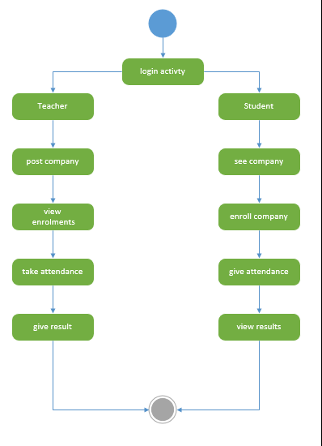

* 1. **FEATURES OF NEW SYSTEM**

1) First time login page.

2) Student Signup Page.

3) Select campus Drive and enroll in it.

4) Scan barcode with changing images.

5) Professor log in page and attendance taking page.

6) Send data to server and process.

7) Professor make campus drive option.

8) Professor should see total number of students present at attendance time

9) Professor and students should be able to view attendance per day, per month.

10) Delete attendance by faculty.

11) send Result of each round.

12) View result by all students.

* 1. **Class Diagram**

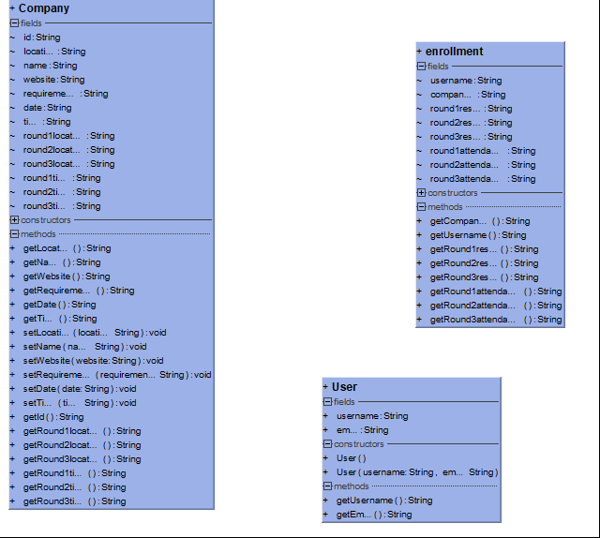

* 1. **SYSTEM ACTIVITY**

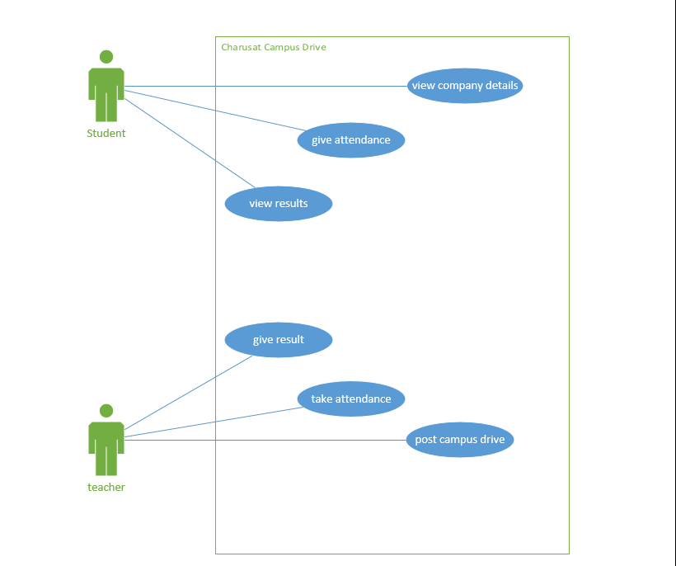

* 1. **SEQUENCE DIAGRAM**

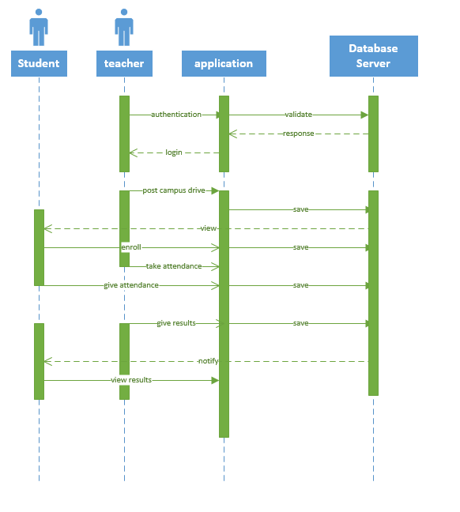

* 1. **DATA FLOW DIAGRAM**

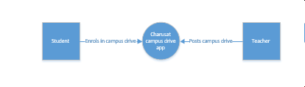

* 1. **DATA MODELLING**
     1. **ER Diagram**

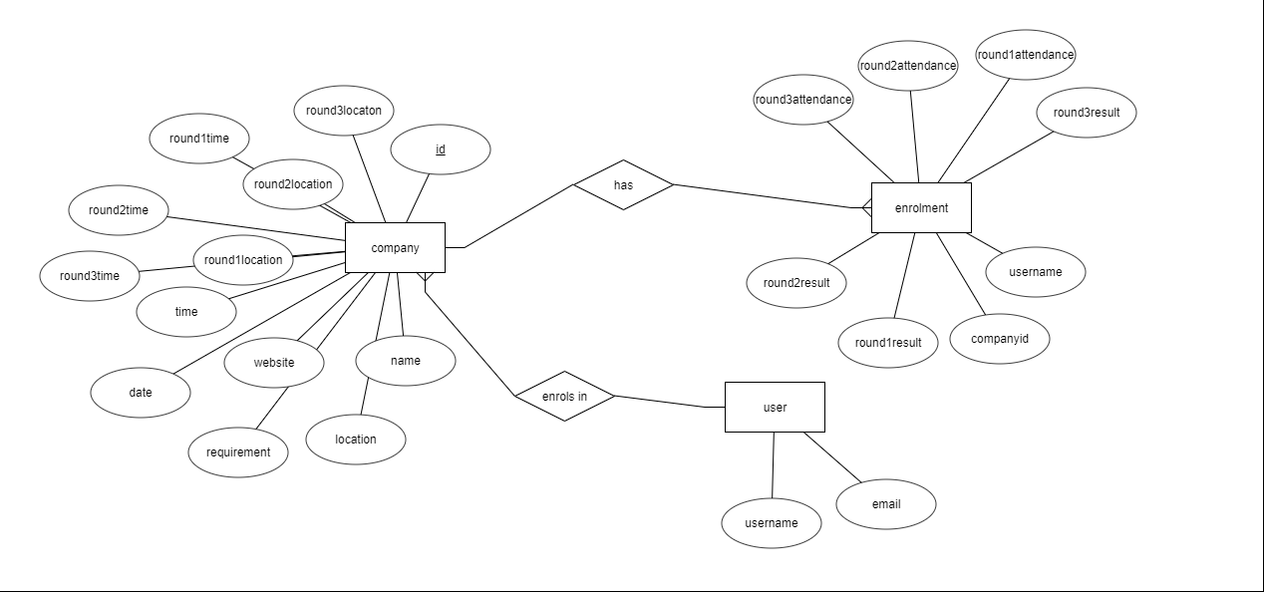

* 1. **LIST OF MAIN MODULES OF NEW SYSTEM**

Qr code scanner

Notification manager

* 1. **SELECTION OF HARDWARE AND SOFTWARE AND JUSTIFICATION**

We have selected android platform and android studio for coding as majority of college student have android smart phones.